**Report on FYUGP Inauguration Programme (വിജ്ഞാനോത്സവം)** **Mahatma Gandhi College, Iritty** **Date: 01 July 2025**

The First Year Undergraduate Programme (FYUGP) Inauguration Ceremony വിജ്ഞാനോത്സവം for the academic year 2025–26 was conducted at Mahatma Gandhi College, Iritty, on 1st July 2025 at 10:00 AM. The programme was a significant event marking the formal commencement of the new academic journey for first-year students.

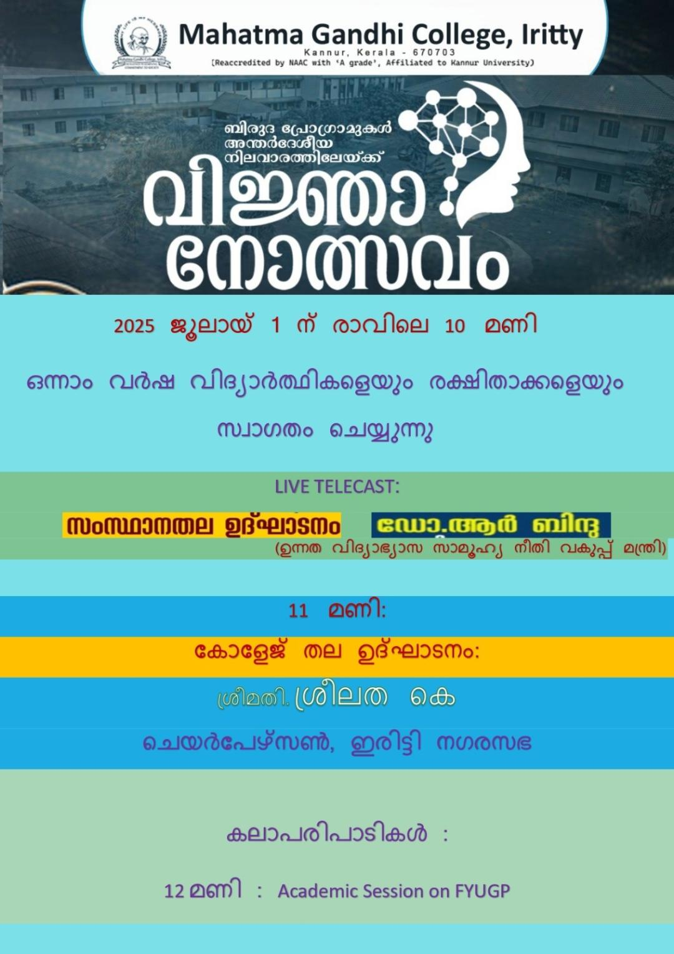

### **Programme Overview:**

The event began with a **Prayer Song**, setting a solemn tone for the inaugural function. Dr. Bijumon R, FYUGP Coordinator, delivered the **Welcome Address**, extending warm greetings to the dignitaries, faculty, students, and parents.

The **Presidential Address** was delivered by **Dr. Swarupa R**, Principal of Mahatma Gandhi College, Iritty. She spoke about the institution’s commitment to academic excellence and holistic development.

The **Inaugural Address** was given by **Smt. Sreelatha K**, Chairperson of Iritty Municipality. She encouraged students to actively engage in their academic and civic responsibilities.

**Sri. Chandran Thillankeri**, College Manager, delivered the **Keynote Address**, focusing on the transformative power of education and the opportunities provided by the FYUGP.

Several dignitaries were present and contributed to the significance of the event, including:

* **Sri. Valsaraj K**, Secretary, Iritty Educational Society

### **Felicitation:**

The following dignitaries offered felicitations and shared their best wishes:

* **Sri. Sameer P V**, Councillor, Iritty Municipality
* **Smt. Sindhu**, Councillor, Iritty Municipality
* **Sri. Muraleedharan**, Vice President, PTA
* **Dr. Aneesh Kumar K**, Coordinator, IQAC
* **Mrs. Sandhya C V**, Head, Department of Physics
* **Dr. Reshma P K**, Head, Department of Computer Science
* **Dr. Jayasagar Adiery**, Head, Department of Commerce
* **Ms. Hima K**, Head, Department of Management Studies
* **Dr. Manju C K**, Department of Chemistry
* **Ms. Mini John M J**, Junior Superintendent

The **Vote of Thanks** was proposed by **Mr. Sebin George**, PTA Secretary, who expressed gratitude to all dignitaries, organizers, and participants for making the event successful.

